24School

A shared study platform for students around globe



**Proposed by:**

**Abdullah Al Mamun (1305003)**

**Md. Rafid Ul Islam (1305063)**

**Partha Chakraborty (1305117)**

**Prepared for:**

**CSE-324 Software Development, January 2017**

**Table of Contents**

1. **Introduction ………………………………………………………………………….3**
2. **Features ……………………………………………………………………………….4**
3. **Process ………………………………………………………………………………….6**
4. **Report …………………………………………………………………………………..7**
5. **User Interface ……………………………………………………………………….8**
6. **Project Schedule ………………………………………………………………….9**
7. **Benefits …………………………………………………………………………………10**

**1. Introduction**

In this semester, we are going to develop a system that offers collaborative learning facilities to the people all over the world. Our primary target audiences are the college students. Throughout this report, we will be discussing about the features and the implementation details in brief. At the end, we will see a proposed Gantt Chart of our project schedules.

From a very high level view, our system will have following features. Students will be a peer to peer tutoring system and also a platform for group study (that we are aliasing as ‘Canvas’).

There will be also a course management system where teachers will create courses, and students will enroll to them. Details will be discussed in the features section.

Additionally the system will have a collaborative Question/Answer forum where a learner can get answers from a specialist from any corner of the world.

**2. Features**

Our system will have mainly following 5 features:

1. Canvas
2. Course Management
3. Project Management
4. Forum
5. Messaging

**Feature 1- Canvas:**

* A user will be able to create a group where he will invite other users to join.
* There will be a drawing board where users can write or draw anything.
* All users will notice any change in their canvas in real time. Canvas will also offer a real time code sharing facility.
* All users in the group will have the right to invite other users to the group. A user cannot join multiple canvases at the same time.

**Feature 2- Course Management:**

* Any user can create a course. He will give the course details: course name, duration, pricing (free or paid) etc.
* By default the course creator will be the course co-ordinator but he can also invite other users as course co-ordinators.
* Course co-ordinators will be able to enroll a user, add a notice, give homeworks with submission link, see and grade submitted homeworks.
* Users who want to take the course will send enrollment requesta. After getting accepted by a co-ordinator, they will be able to see the notice board, see the homeworks given by the co-ordinators, and submit homeworks.
* They can also ask a question in the course forum.

**Feature 3- Project Management:**

* A user can add a project from a version controlling system (it is yet to be decided). He will be the only ‘team member’ by default.
* Team members can invite other users as team members.
* Team members can invite one or more users as project supervisors.
* Project supervisors can assign tasks for the team members and monitor the progress of the project.

**Feature 4- Forum:**

* A user can ask a question in the forum.
* Other users will be able to add answers to the question.
* All users can comment on the question and the answers.
* A user can upvote or downvote the question or the answer.
* The number of upvotes and downvotes a user receive on his question or answer will be used to update his rating.

Feature 5- Messaging:

* A user can send message to any other user except the ones who blocked him.
* Users can reply to the messages they receive.
* A user can block another user from sending messages to him.

**3. Process**

* At first we are planning to make the use case diagrams.
* Then we will design the database. To do this, we have to design the ER diagram and then we will design the schema of the database.
* After that we will make the class diagrams. By this time we plan to learn the technical requirements to develop the project.
* After the class diagrams are ready, we will focus on developing the subsystems. Unit testing will be done during the development phase.
* Then we will merge the subsystems to make the whole system.
* Integration testing and functional testing will be done after that.
* If any bug is found, we will revise the corresponding code sections.
* We will submit the project after the testing has been finished successfully.

We are planning to use the following technical features to implement the system.

* Oracle SQL database
* Java programming language
* HTML 5
* Spring framework
* Angular JS framework
* Hibernate framework
* Bootstrap framework
* GitHub API
* Open Authorization (OAuth)
* etc.

4. Reports

We will generate the reports on:

* Number of monthly active users
* Average number of posts per day in a month
* Number of discussions on a particular field in a month
* User reviews to the features
* etc.

5. User Interface

As a sample, we attached the outlooks of some of the webpages of our system.

6. Project Schedule

The schedule of the project is shown in the following Gantt Chart.

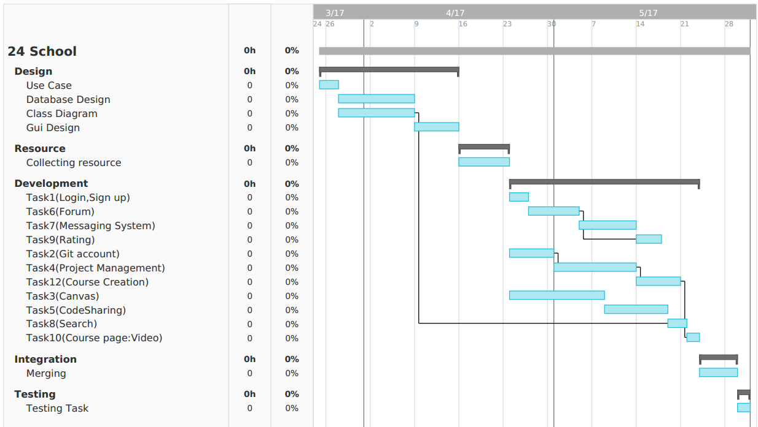

7. Benefits

We believe that this system will be helpful to the learners all over the world. The canvas will help people to overcome the difficulties of typing mathematical expressions, as they can share their handwritings. Users can even take or attend a class from a remote location using this feature.

Newbies can take the advantage of the forum. We hope people are helpful, so they will help answering questions of others. The rating system will encourage people to behave cooperatively.

The course management and project management systems will help students to keep themselves in touch with their teachers. Project supervisors will be able to monitor the progress of their supervisees if they cannot meet for any reason.

This system is only for the purpose of education and we hope it will help a lot of learners to overcome some of the difficulties they are facing for long.